Practice
Solving Quadratic Equations by Graphing

Solve each equation by graphing.
1. $x^{2}$ – 5x + 6 = 0 2. $w^{2}$ + 6w + 9 = 0 3. $b^{2}$ – 3b + 4 = 0
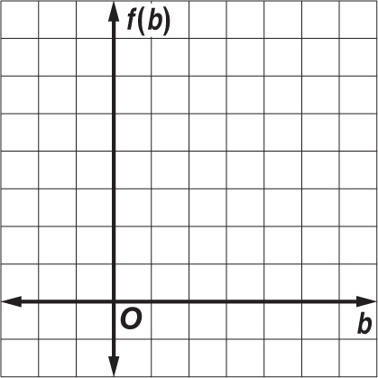
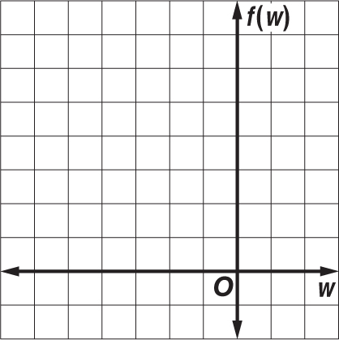
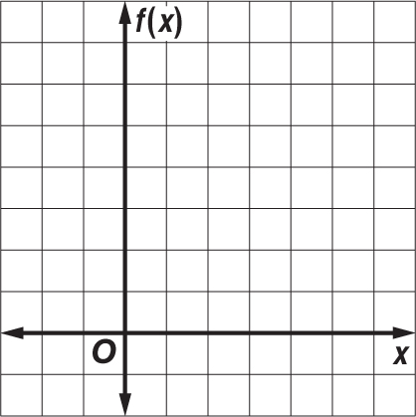

Solve each equation by graphing. If integral roots cannot be found, estimate the roots to the nearest tenth.
4. $p^{2}$ + 4p = 3 5. 2$m^{2}$ + 5 = 10m 6. 2$v^{2}$ + 8v = –7
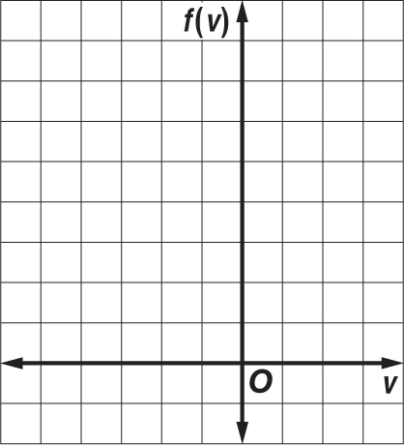
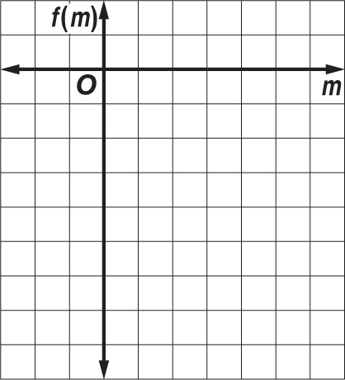
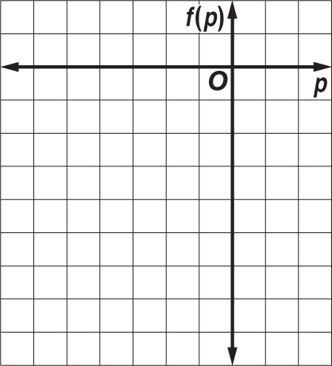

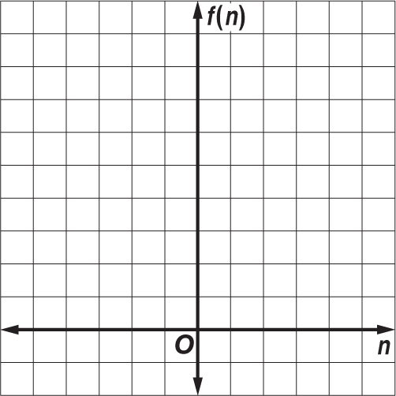
7. NUMBER THEORY Two numbers have a sum of 2 and a product of –8. The quadratic equation –$n^{2}$ + 2n + 8 = 0 can be used to determine the two numbers.

a. Graph the related function f(n) = –$n^{2}$ + 2n + 8 and determine its
x-intercepts.

b. What are the two numbers?

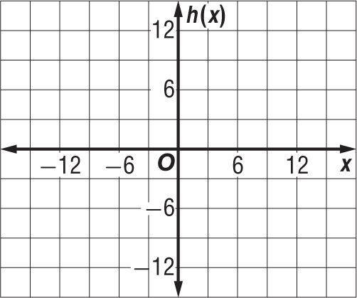
8. DESIGN A footbridge is suspended from a parabolic support. The function h(x) = – $\frac{1}{25}x^{2}$ + 9 represents the height in feet of the support above the walkway, where x = 0 represents the midpoint of the bridge.

a. Graph the function and determine its x-intercepts.

b. What is the length of the walkway between the two supports?

